1/11/2018

1.

Fix the scroll bar(scroll-thumb) in the chatbox from green color to grey.

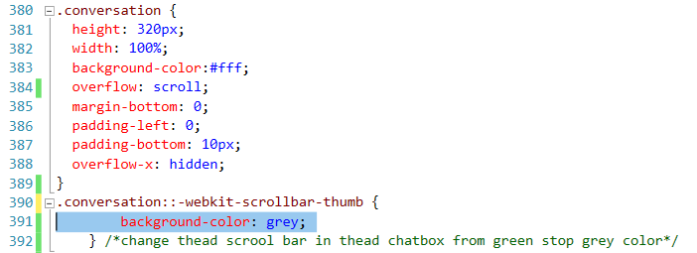

More about Scroll:

::-webkit-scrollbar{

Width:1em;

}

::-webkit-scrollbar-track{

-Webkit-box-shadow: inset 0 0 6px rgba(0,0,0,0.3)

::-webkit-scrollbar-thumb{

background-color:grey;

outline : 1px solid slategrey;

}

::-webkit-scrollbar {

display:contents;

overflow-y:hidden; /\*for hiding the scroll bar\*/

}

2. when a user submit a review without an image, it will automatically add a blank image, get rid of the blank image, only have reviews.

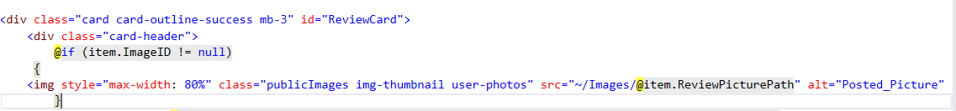

3. Create a 1000 character limit for the description area when adding a travelogue post!

<textarea maxlength = “1000”>

4. Make the comment box resizable

.content {

Resize: both;

Overflow: auto;

}

Make sure there biggest container doesn’t have max-width to limit.

1/12/2018

When a review is created without an image the summary of the review that is displayed back to the user should not display any image as opposed to displaying the users profile pic

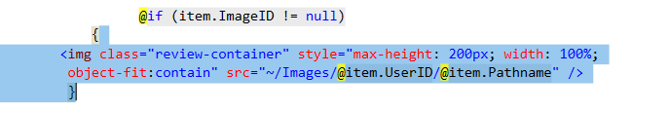

1/16/18

1. Fix the 2 blank scroll bars appear on the right hand side of the home page.



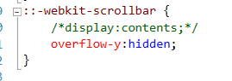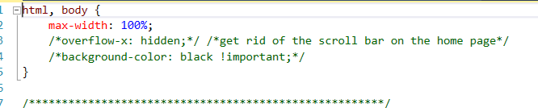

1. only the comment modal on the travelogue page should be resizable not the delete and flag modals

<div class="modal-content" id="comments">

#comments {

resize: both;

overflow: auto;

}

(Add a id, so we can point right into the right box that we want to resize)

1. create an error message when someone tries to add a description of more that 1000 characters for a Travelogue post

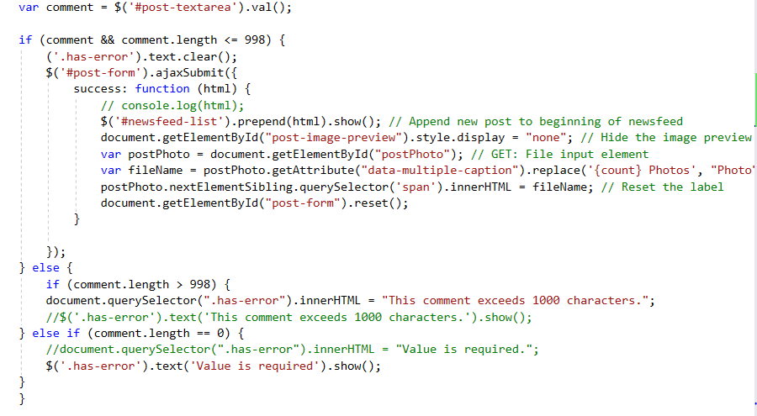

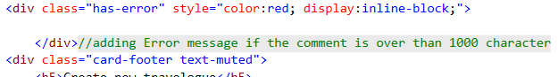

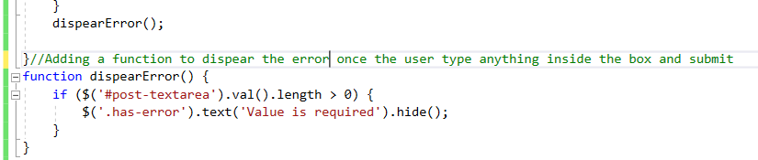

1/17/18

1. move and update the link on the Review summary view that comes up after you successfully create a view so that the link to see more review displays below the Review Created Successfully Message (see description)

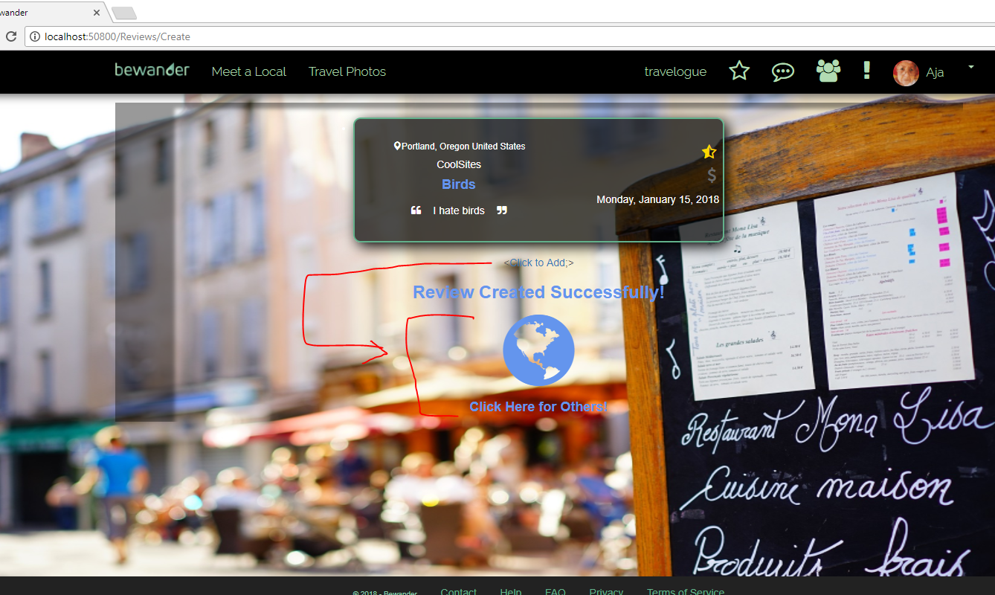

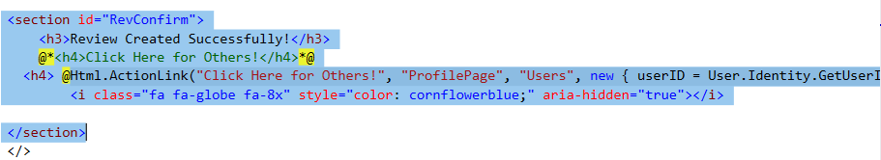

1. ensure the thumb icon falls in the same place on the card for photos with 0 likes on the Travel Photos page

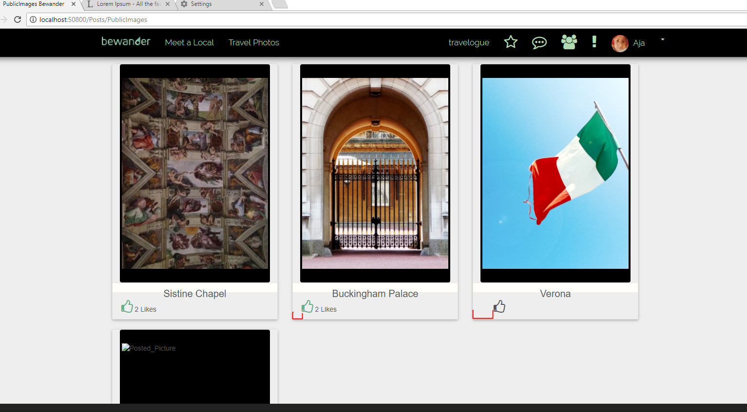

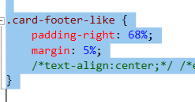

1. fix the way additional comments are displayed in the comments modal so that there isn't two sections with scroll bars within the comment modal

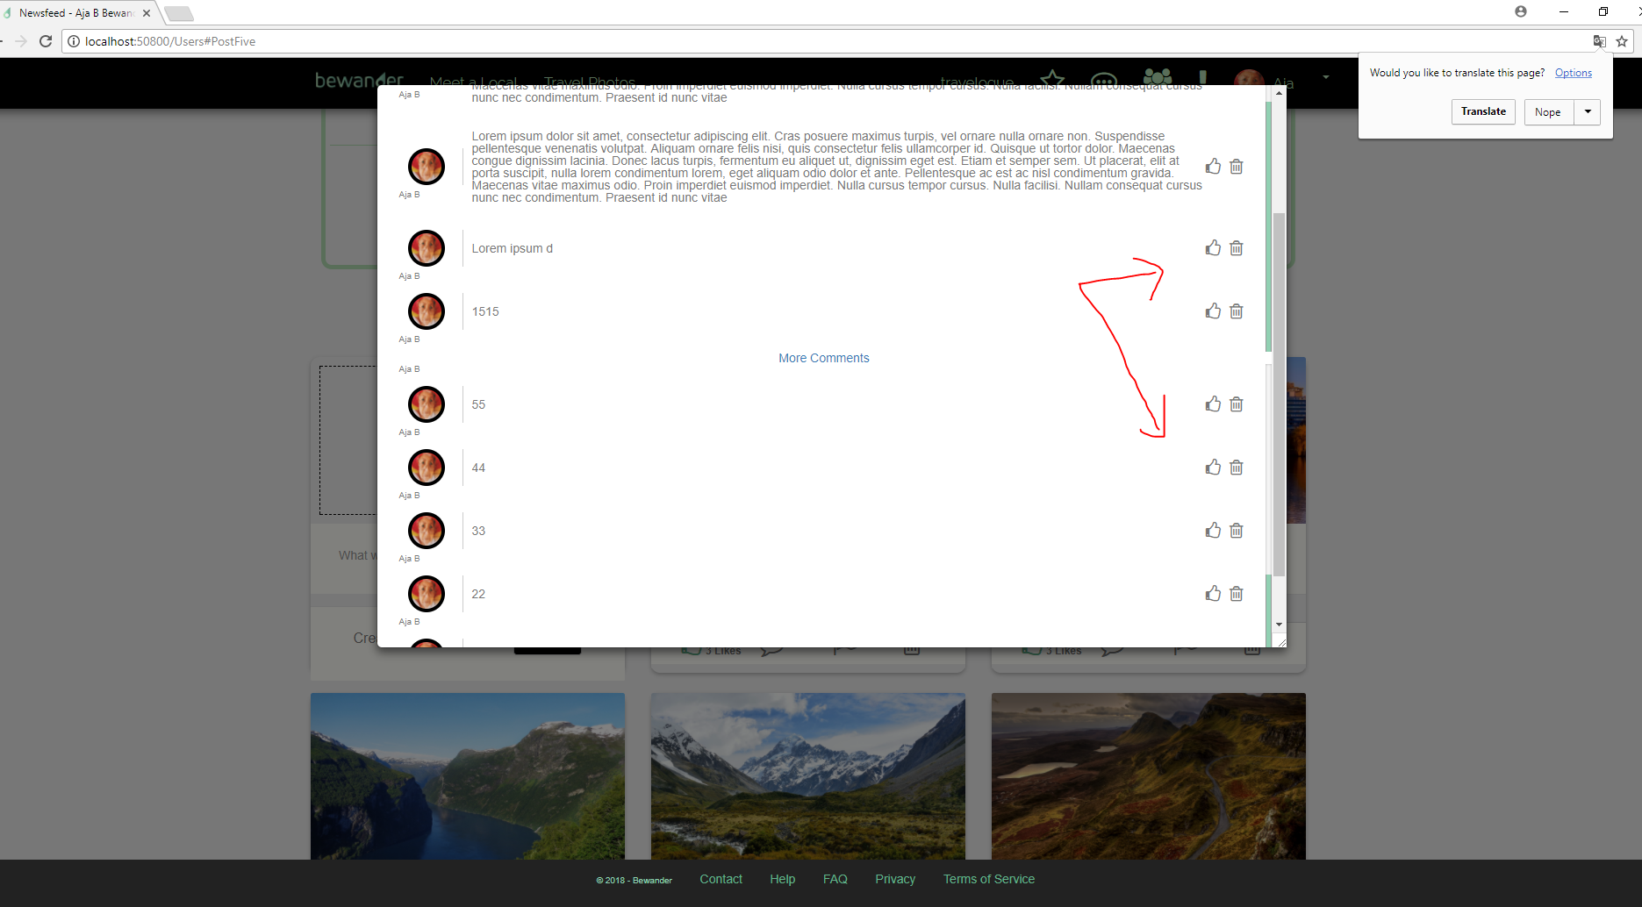

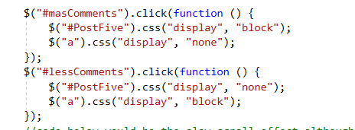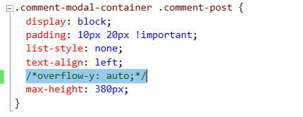

1/18/2018

1. build out the comment modal on the Travelogue page to include description

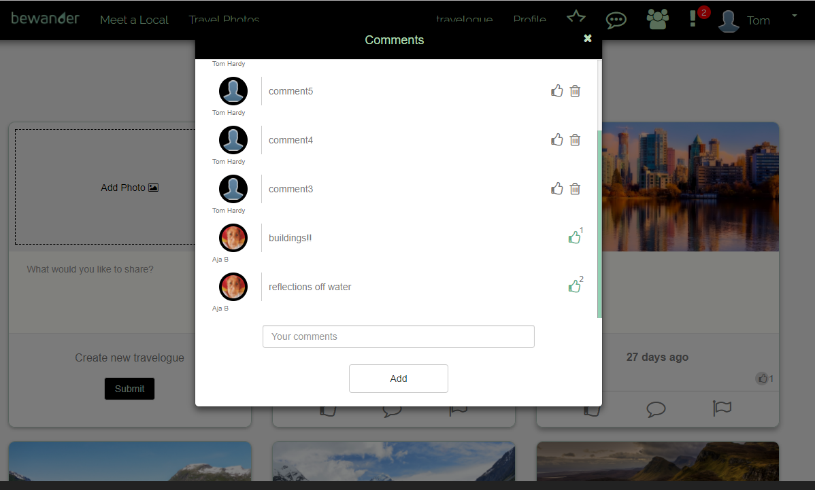

1. Fix the ViewModel

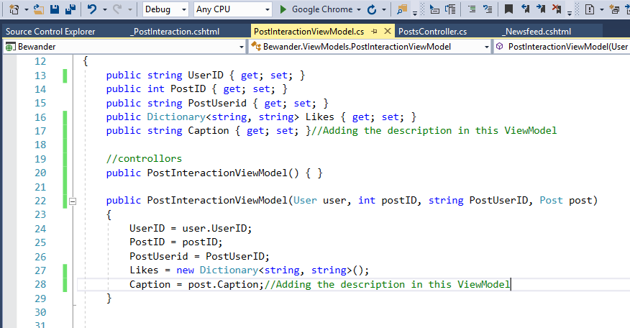

1. fix the Controller

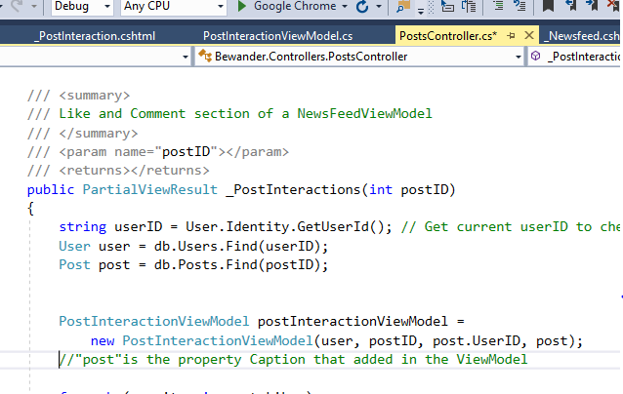

1. fix the .cshtml file

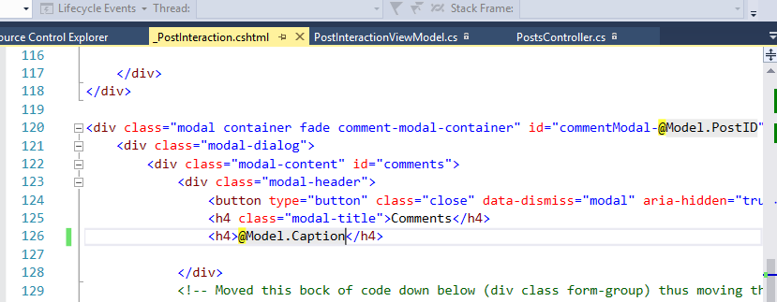

1. debug why the "more comments" link in the comments modal is only working on the first post of the travelogue page as opposed to all posts

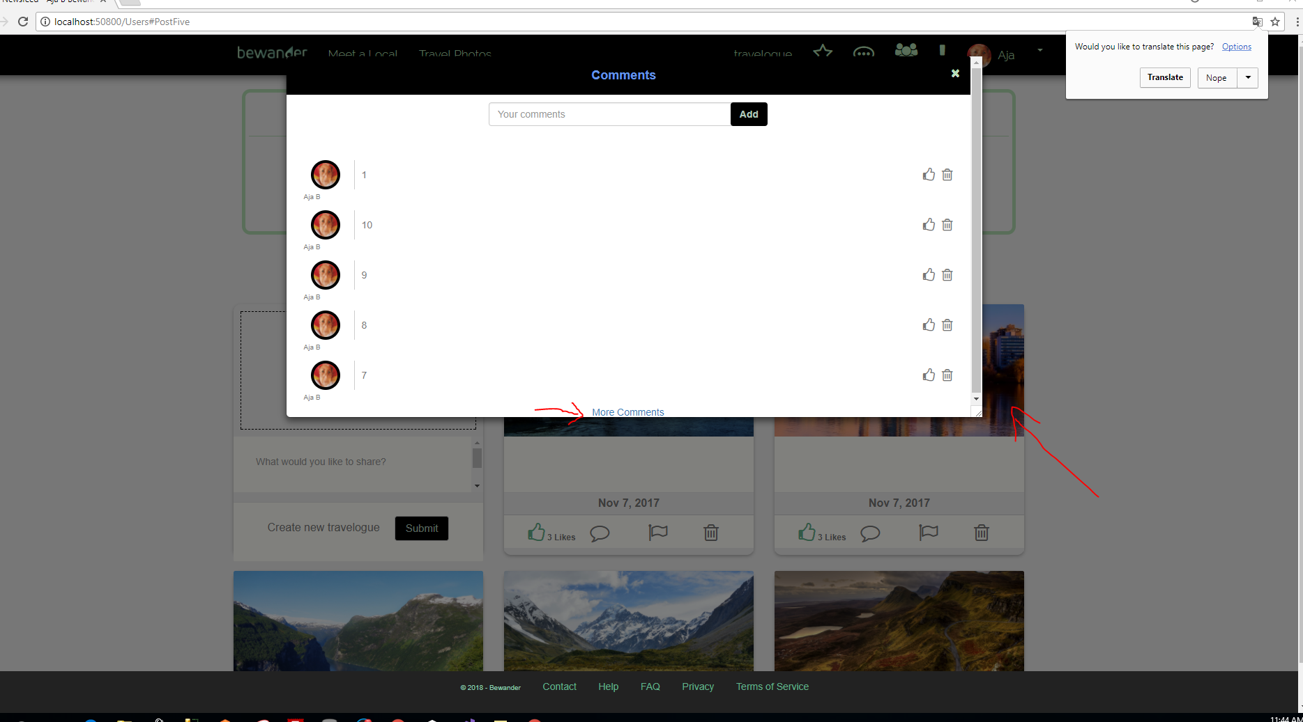

1. Because “ID” is unique, so adding the PostId to make the id=”PostFive” unique.

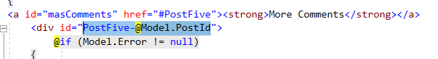

1. Go back to the VIewModel to add PostId property, and add it in the constructure.

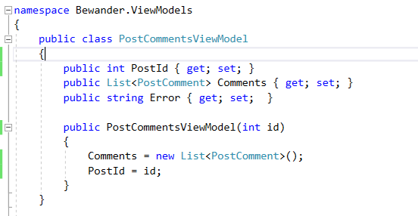

1. Go to controller, pass in the “id” also. And loop around to find “GetComments” to add in “id ” to all the field

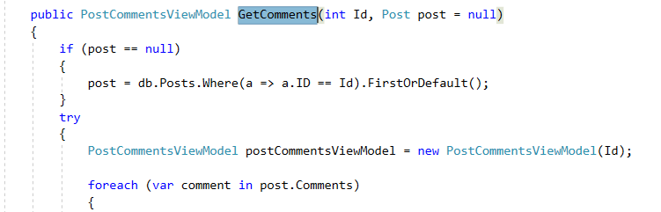

Also changed the “id” into “class”, otherwise it will have same issue on the function parts.

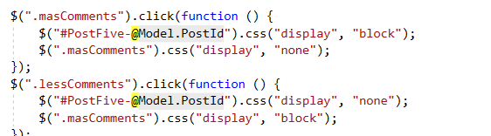

1/19/2018

1. add padding above the placename so that it doesn't fall so close to the picture on the Travel Photos page

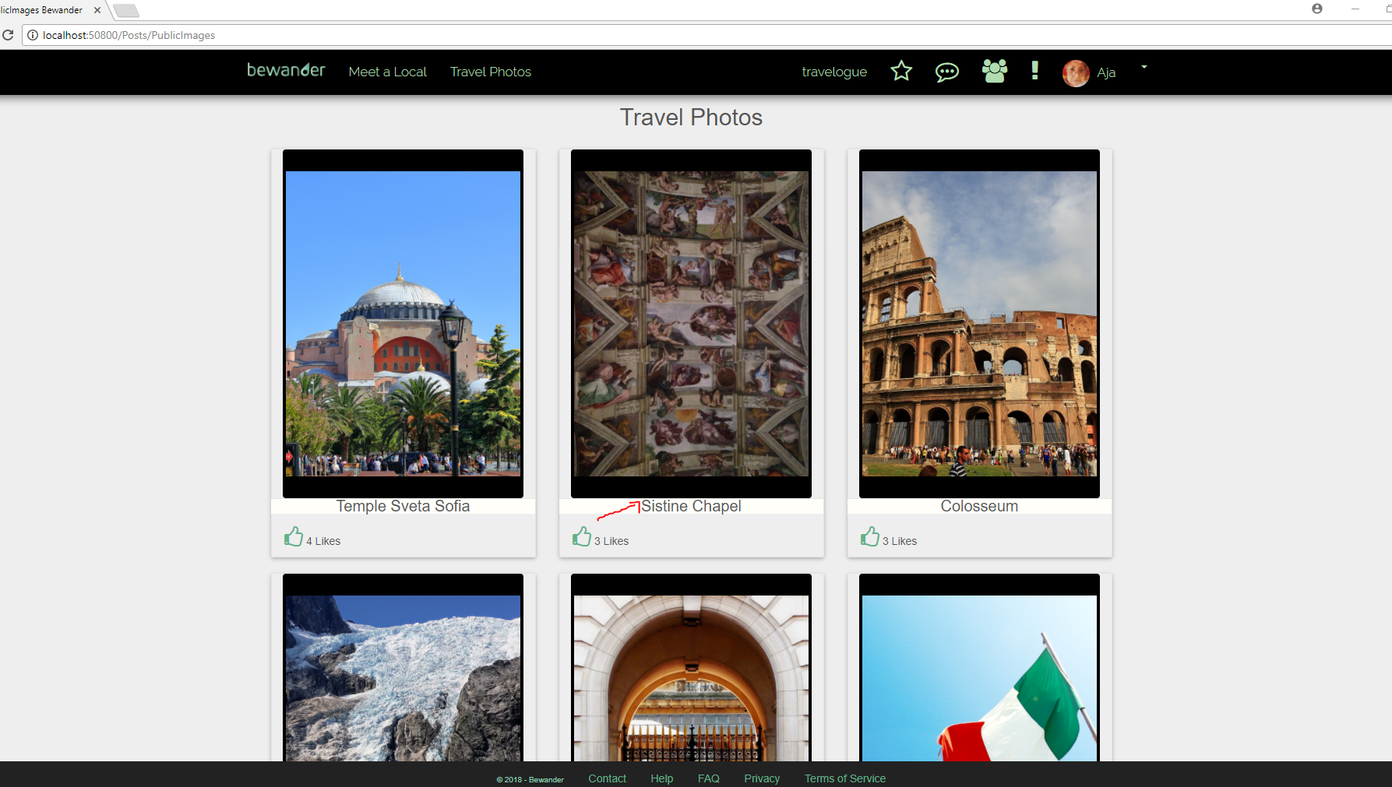

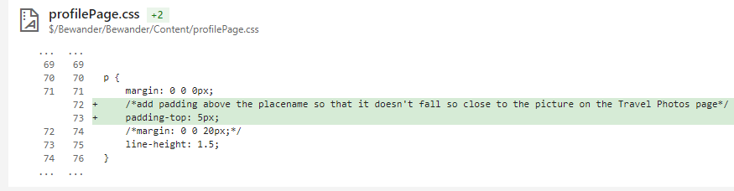

1. display the timestamp for the comments in the comment modal underneath each comment

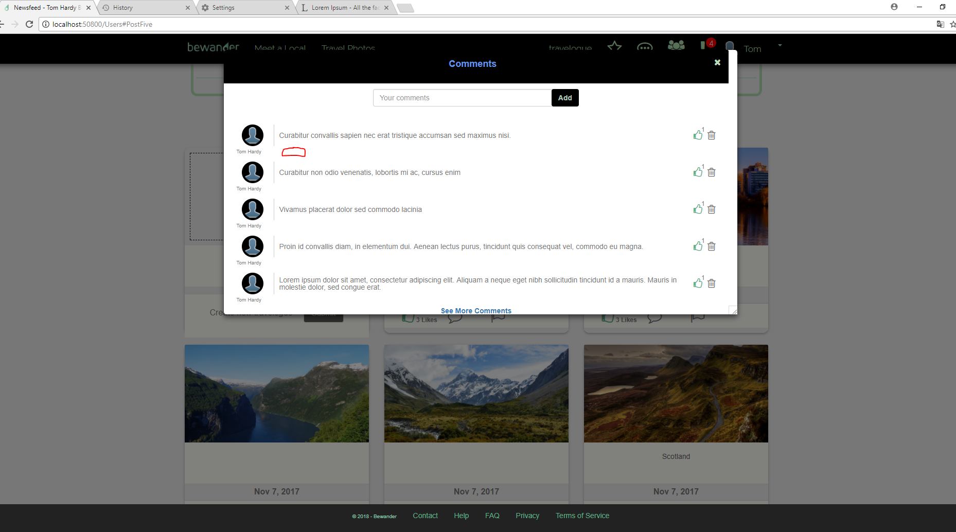

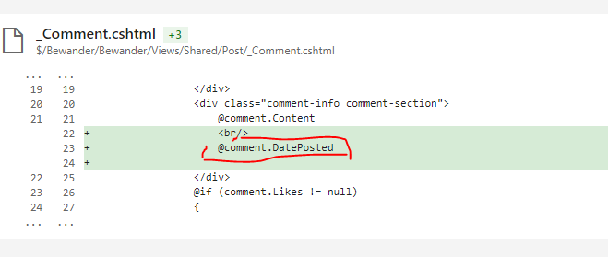

*After Change:*

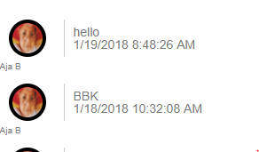

1. modify the logic for displaying timestamps so that if there are a group of messages with the same time stamp they all display under one time stamp

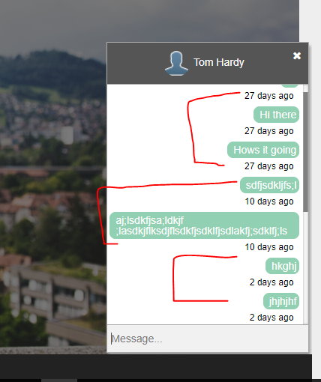

1. move the "Less Comments" to display after the 5th comment where the "More Comments" link was previously displayed before expanding the view to include more comments

